**Introduction**

This test project is developed using ASP .Net Web application with .Net Framework 4.7.2 and C# as the server-side codes. UI is using free Bootstrap template.

The reason ASP .Net Web application was chosen because it is easier to setup in the local environment as the Web and server-side codes is in a single Solution. C# is an object-oriented programming where the logic can be encapsulated into an object, and it can be interreact with other objects easily. Software design principles can be implemented for application that develop using object-oriented approach such Design Patterns, SOLID principle and TDD (Test Driven Development). Bootstrap made the website responsive and lot of ready components and javascripts libraries.

**Setup and Configuration**

1. Install (Visual Studio 2019 recommended) or any other Visual Studio version with .Net Framework 4.7.2 and ASP Web application template.
2. Clone the source code from https://github.com/yewmeng80/NumberToWordsConverter.
3. Open NumberToWordsConverter.sln
4. Build the solution and press F5 to run the web application.
5. If running the web application without building the solution after cloned, error as in the image below. This Solution is using .Net Framework 4.7.2. and not sure why it pointing to 4.8.

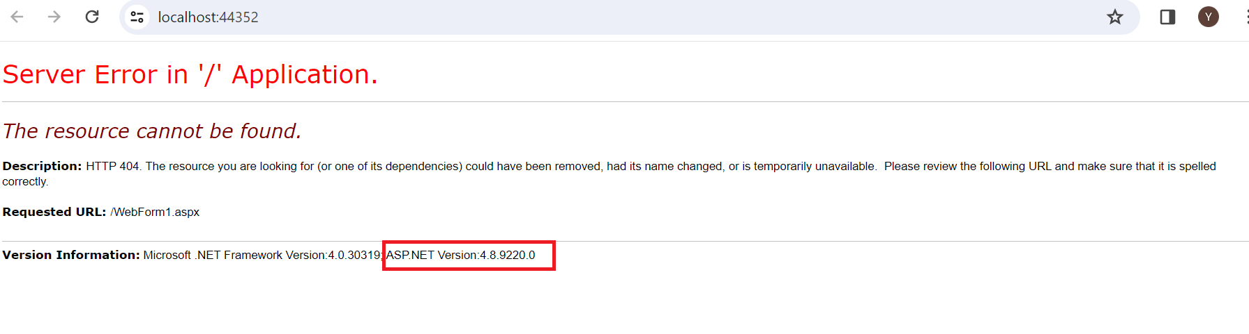

1. To fix this issue, clean and build the solution. The web application should be able to run   
   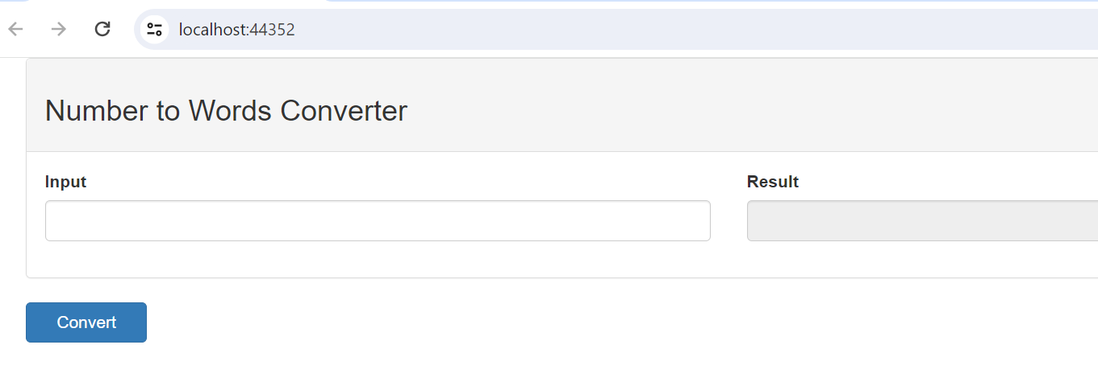

**Test Harness**

* Test project NumberToWordsConverterTest created to validate the codes in the NumberToWordsConverter using TDD approach. Code coverage is 100% for components (C# Class).

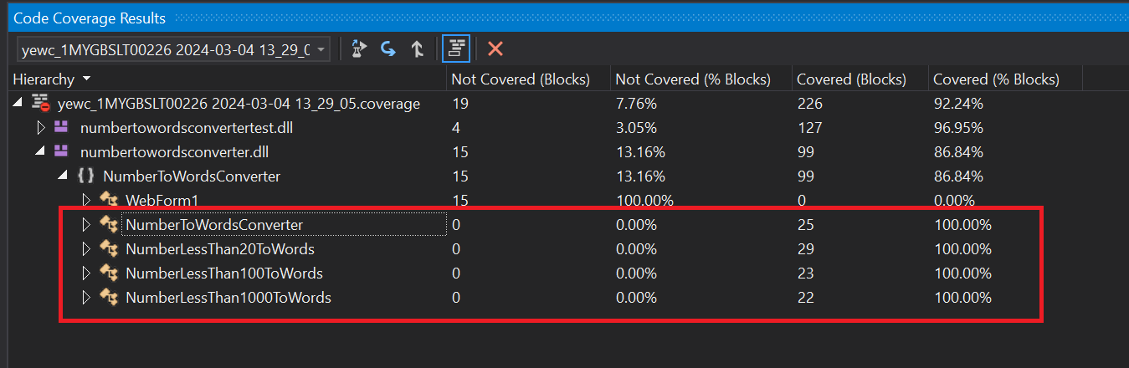

* Run the web application for UI testing (refer to setup and configuration). Fill in number in the Input field and click on Convert “button”. Number in words will be displayed in Result field.

